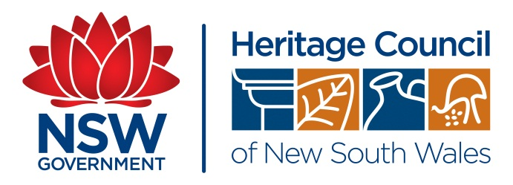

heritage talks 2013

Wednesday 19 June
at the Heritage Branch, Office of Environment & Heritage
3 Marist Place, Parramatta
~ Public Sydney – Drawing the City ~
program
Chair: Prof. Lawrence Nield
Chair of the NSW Heritage Council
5.15 – 6.00 | Arrival and light supper
6.00 | Welcome & Acknowledgement of country | Chair: Prof. Lawrence Nield, Chair of the NSW Heritage Council
6.00– 6.10 | Introduction | Prof. Lawrence Nield Chair of the NSW Heritage Council, Professor of Architecture at the University of Newcastle, Principal STUDIO NIELD
6.10 – 6.30 | Book Launch | Minister Robyn Parker
6.30 – 7.30 | Public Sydney- Drawing the City | Philip Thalis, Principal – Hills Thalis Architecture+ Urban Projects  Peter John Cantrill, Principal Director Tzannes Associates Architects
7.30 – 8.00 | Thanks | Prof. Lawrence Nield Chair of the NSW Heritage Council, Professor of Architecture at the University of Newcastle, Principal STUDIO NIELD
8.00 | Close

Note: The book Public Sydney- Drawing the City will be available to purchase at the venue.

Booking form – Launch of book PUBLIC SYDNEY by Minister Robyn Parker
And a talk by the authors about the book
heritage talks 2013

Wednesday 19 June

As seats are limited, please book early ~ Closing date Friday 14 June ~ We will confirm your booking with you FREE
Starting at 5:15 PM with arrival & light supper
at the Heritage Branch, Office of Environment & Heritage
3 Marist Place, Parramatta

Complete and email this form to heritage@heritage.nsw.gov.au or fax to 02 9873 8599 or post to Reception
Person #1 please complete your contact details type into hi-lighted areas of this form
Name/s |  | Organisation
Address |  | Postcode
Work phone |  | Home phone
Mobile |  | Email
Any special requirements e.g. dietary, access etc

Person #2 please complete your contact details type into hi-lighted areas of this form
Name/s |  | Organisation
Address |  | Postcode
Work phone |  | Home phone
Mobile |  | Email
Any special requirements e.g. dietary, access etc
For additional people please supply contact details

A confirmation e-mail will be sent to confirm you’re booking once form is received. If you do not receive a confirmation e-mail it could be because of non-availability of further spaces. Please contact the Heritage Branch on 02 98738500 to avoid disappointment.

Note: The book Public Sydney- Drawing the City will be available to purchase at the venue.

Heritage Branch, Office of Environment & Heritage
ABN 30 841 387 271 BSB 032 001 Account 205 936
Locked Bag 5020, Parramatta NSW 2124~Phone: 02 9873 8500 ~ Fax: 02 9873 8599 ~ www.heritage.nsw.gov.au

