Position Description

Position title: | Senior Heritage Officer
Position number: | 50920103
Group: | Planning
Division: | Planning Implementation and Heritage, Heritage Victoria
Classification: | VPS Grade 5
Employment type: | Fixed term until 30 June 2025 - Flexible
Position reports to: | Vicki McLean, Principal, Major Projects
Usual Place or Places of Work: | 2 Lonsdale Street, Melbourne
Position contact: | Erin Williams, Manager Strategic Projects and Operations 0419 091 216

Role Purpose
About Us
The Department of Transport & Planning brings together all transport modes to design, plan, build and operate Victoria's transport system. Our job is to further integrate the transport network and improve the delivery of services to Victorians for simpler, quicker and safer journeys that connect people and places and support Victoria's prosperity and liveability.
We’re focused on outcomes that deliver more choice, connections and confidence in our travel, ensuring the whole transport network works as one to deliver better services and outcomes.
The Department is committed to building a culture where we say 'yes' to flexible work arrangements, provide personal and professional development programs and support ways of working that help employees balance work and life.
The Department is an equal opportunity employer and welcomes applicants from a diverse range of backgrounds, including veterans, people who identify as Aboriginal and Torres Strait Islander, have a disability, are from varied cultural backgrounds and those who identify as LGBTIQ+. The Department provides workplace adjustments for applicants with disabilities.
Planning is a Group within the Department of Transport and Planning, and is responsible for a number of significan Statutory Authories and Administrative Offices ranging in size, complexity and core functions. The Planning Group manages the state’s planning, building and heritage systems, including develping long-term, integrated land-use strategies and policies, adminstering statutory planning responsiblities and facilitating urban development.
Heritage Victoria is the regulator responsible for the control of the State’s historic heritage. It delivers the functions of the Heritage Act 2017 which enables the identification, protection and management of Victoria’s State significant heritage places and objects, historical archaeological sites, and maritime heritage. Heritage Victoria maintains the Victorian Heritage Register, the archaeological Heritage Inventory, and the Historic Shipwrecks Database. It advises on heritage practice, and seeks to increase the recognition of Victoria’s heritage, support the retention of significant values when heritage placs are adapted or changed, and communicates the benefits of investing in heritage assets.
About the Role
The Senior Heritage Officer will work within the Major Projects team at Heritage Victoria. This multi-disciplinary team was established to drive strong heritage outcomes on major infrastructure projects including Metro Tunnel, Level Crossing Removal Project, Suburban Rail Loop, North East Link, Major Road Projects, Inland Rail, and the Melbourne Art Precinct Transformation.

The Senior Heritage Officer will work collaboratively and represent Heritage Victoria in matters relating to the management of places on the Victorian Heritage Register which may be affected by the Big Build, and other projects as required. This may include representation of Heritage Victoria’s interests through the development of Environmental Effects Statements or other approvals processes, assessment of permit and exemption applications including the drafting of conditions of approval commensurate with project impacts, contribution as relevant to other statutory processes, attendance at regular project meetings, attendance on site, statutory compliance, and the provision of objective advice to ensure projects achieve outcomes consistent with good heritage practice and the requirements of the Heritage Act 2017.

POSITION OUTCOMES
- Provide authoritative specialist heritage advice to a wide range of stakeholders including Ministers, senior representatives, local government, other agencies, community groups and the public.
- Prepare high quality, factually correct and objective reports, papers, submissions, presentations, briefs and correspondence, that demonstrate a detailed understanding of the policy, political and legal context in a timely manner; maintaining high quality record keeping.
- Establish, manage and utilise effective collaborative relationships with key stakeholders, including other state government departments, agencies, contractors and representatives to facilitate the effective representation and assessment of heritage matters on major transport projects.
- Lead the assessment of permits and permit exemptions in accordance with statutory timeframes and prepare for, and represent the Executive Director at Heritage Council hearings, as required.
- Represent Heritage Victoria as required through the planning, approvals and delivery phases of major transport projects.
- Mentor, coach and provide guidance to team members, contributing to a high-performing team that is proactive, responsive and has a strong culture consistent with the department’s behaviours.
- Work flexibly and collaboratively across the business to deliver business unit, group and DELWP priorities and initiatives as required.
- To practice cultural safety by creating environments, relationships and systems free from racism and discrimination so that people can feel safe, valued and able to participate.

Key selection criteria
KNOWLEDGE AND SKILLS
Future focus
- Develops objectives that link to broader team and organisational objectives.
- Considers future aims and goals of the team and organisation in prioritising own and others' work.
- Integrates relevant technologies into own ways of working and supports others in this.
- Proactively stays up to date with best practice and leading developments relating to expertise and area of work.

Project delivery
- Defines tasks to be delivered to meet agreed outcomes.
- Coordinates and guides others in the execution of work activities.
- Monitors progress of tasks against plans and takes corrective action when required.

Political and Organisational Context
- Understands issues and pressures to which the organisation has to respond.
- Understands the reasons behind the organisational climate and culture.

Communicate with impact
- Makes a positive impression on others and comes across with credibility.
- Communicates orally in a manner that is clear fluent and holds the listeners’ attention.
- Able to deal with difficult and sensitive topics and questions.

PERSONAL ATTRIBUTES
Outcomes Thinking (Accomplished level)
Establishes mechanisms to monitor impact of work on the community; Ensures team/ organisation’s operating and delivery model is designed in ways that creates a positive impact on community

Resilience (Applied level)
Gives frank and honest feedback/advice. Listens when ideas are challenged, seeks to understand the nature of criticism and respond constructively; Displays confidence and conviction when communicating an opinion. OR

QUALIFICATIONS and experience
Mandatory
- Tertiary qualification in a heritage related discipline including but not limited to architecture, engineering, planning or conservation and experience in heritage conservation, is required.
- Demonstrated understanding of the philosophical and practical issues relating to the conservation and management of the State’s most significant heritage places is required.
Desirable
- Demonstrated ability to build awareness and understanding of economic and political trends that may affect Major Transport projects and consider the ramifications of these emerging issues and long-term impacts.

ROLE SPECIFIC REQUIREMENTS
- Driver’s License preferred but not essential.
COVID-19 VACCINATION
Mandatory Vaccination Directions
Under the any applicable public health orders, directions or laws, and consistent with DTP’s Vaccination Policy, DTP:
- must collect, record and hold vaccination information about workers who are, or may be, scheduled to work outside their ordinary place of residence; and
- must not permit unvaccinated workers to work for DTP outside of their ordinary place of residence, subject to certain exceptions.

It is an inherent requirement of this position that the employee is ready, willing and able to perform work outside their ordinary place of residence as and when required. As a result, it is a condition of employment that before commencing employment with DTP, the successful applicant is required to provide evidence of being up to date vaccinated against COVID-19, or provide evidence that they are an excepted person (i.e. provide certification from a medical practitioner which confirms the applicant is unable to receive a dose, or a further dose, of a COVID-19 vaccine due to a medical contraindication or an acute medical illness). If an applicant is an excepted person, DTP may impose measures under the Occupational Health and Safety Act 2004 in order to discharge its duties under that legislation.
Failure to comply with this condition of employment will impact your eligibility for employment in this position with DTP.

OTHER RELEVANT INFORMATION
How to apply  Applications including a resume and covering letter are to be submitted online by visiting www.careers.vic.gov.au.  Candidates may also wish to supply a statement addressing the key selection criteria as outlined in the position description. Applications after the closing date will not be accepted.  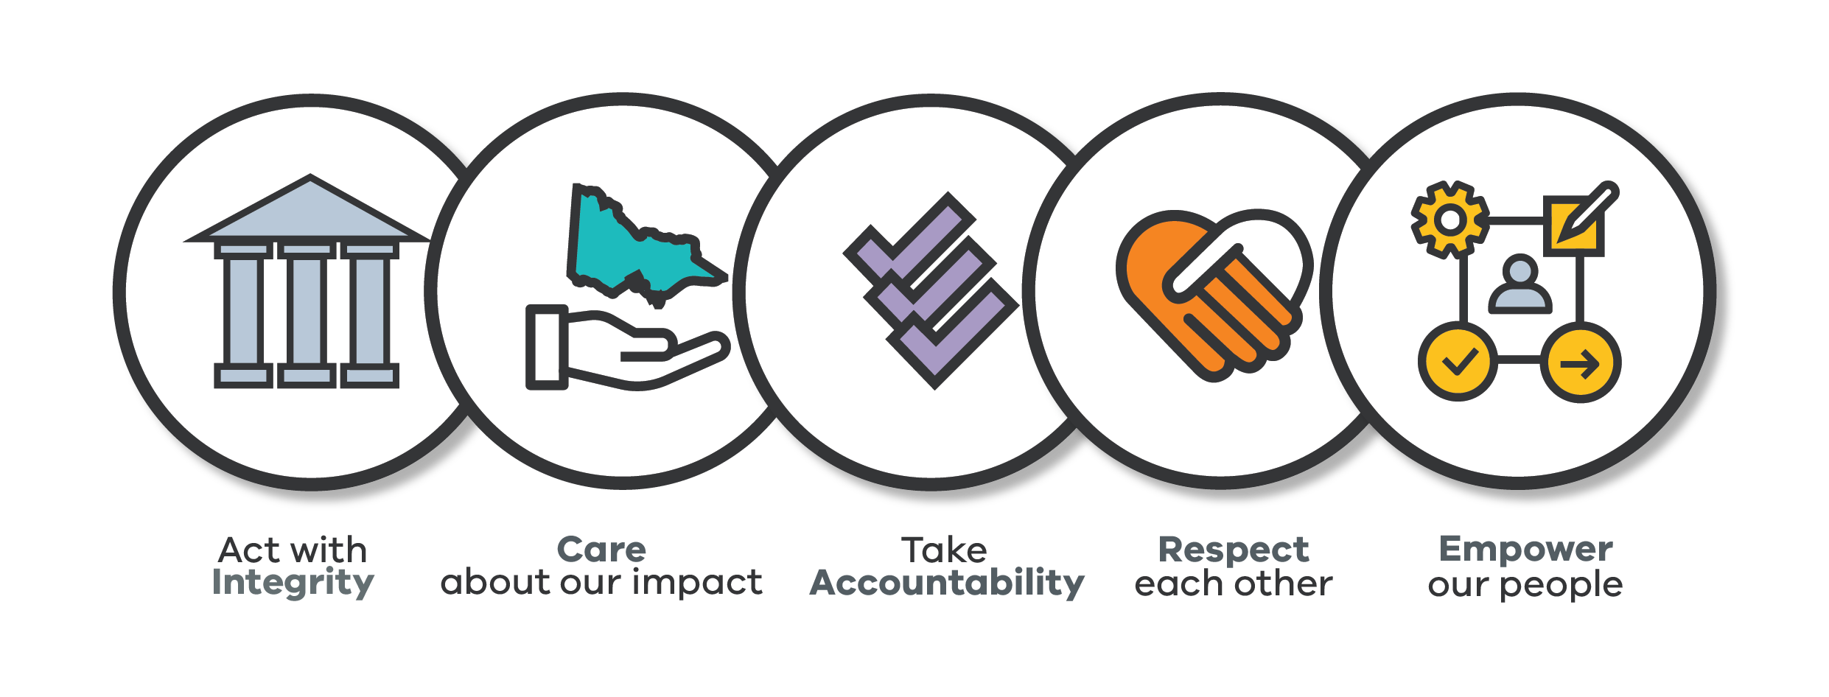  Cultural Values  At DTP, we are commited to building a safe, inclusive and high performance culture through shared actions and behaviours - aligned to our strategy and direction, that empowers our people to deliver on our goals in a constructive way.  To do this we engaged our people in a co-design process to create our own meaningful and fit-for- purpose values. Our Cultural Values are a true reflection of what values and behaviours our people told us matter to them in the workplace and within our strategy and unique mission.  We are commited to living Our Cultural Values – and these are reflected in our internal processes and all people focused programs.  As part of the VPS, we also uphold the VPS values, which are reflected in the VPS Code of Conduct. | Emergency Response Requirements  The department plays a major role in Victoria’s emergency response activities, biosecurity incursions and compliance actions. Employees can be directly employed for these roles or may be called upon to support these activities as required following appropriate training and suitability assessment.  Employment Conditions  Applicants must be an Australian Citizen, Permanent Resident or hold a valid work permit or visa necessary for the nature of the position.  Recipients of Victorian Public Service (VPS) voluntary departure packages should note that re- employment restrictions apply.  Non-VPS applicants will be subject to a probation period of six months.  All new appointments to the department will be subject to a National Criminal Records Check, Misconduct Screening, and a Qualification Check where there is a requirement for a mandatory qualification.  Employees are covered by the Victorian Public Service Enterprise Agreement. The collection and handling of applications and personal information will be consistent with the requirements of the Privacy and Data Protection Act 2014.

WORKING FOR THE DEPARTMENT OF TRANSPORT AND PLANNING
Working with the department presents a wide variety of opportunities, with a range of personal and professional development programs designed to develop our people and their careers. Working closely with industry, business and the community enables you to make a difference to efficient and safe travel for all Victorians. Some of the benefits that we offer you include:  Safety, Health and Wellbeing  The department is committed to providing safe, healthy and workplace for all its people, including contractors and visitors. DTP reinforces its safety focus through embedding expectations of its leaders and people to support health and safety outcomes for all and compliance with all relevant health and safety laws (including the Occupational Health and Safety [OH&S] Act 2004 and its associated regulatory codes)  Flexibility to balance work and life commitments  Working together we can shape our future workplace and workforce to enable us to thrive in the hybrid working environment. The VPS Flexible Work Policy and DTP’s Flexible Work Guidelines are the fundamental planks of our hybrid working strategy, enabling everyone to seek flexible work arrangements. In consultation with managers, employees are able to balance individual preferences with the needs and obligations of colleagues and the organisation. A key focus is the move to a default starting point of employees working three days per week in an office, instead of five. The nature and scope of the flexible options will depend on the requirements of the position. | Learning and Development  We want you to grow, develop and learn with us. The department provides you with access to a range of internal and external learning and development opportunities to support your performance in your role and further your career aspirations. The department also supports relevant study via negotiated financial assistance and leave provisions for approved courses.  Inclusion & Diversity  The department aims to create a workforce that reflects the community, customers, and stakeholders we serve, and advance an inclusive workplace culture that values and optimises the contributions and talents of its diverse workforce. The department delivers a number of inclusion and diversity initiatives, including an all-inclusive employee resource group and specific working groups, inclusion and diversity training, and tailored programs and support for employees.  Mobility  The department has a focus on employees gaining relevant and diverse skills and experiences within the department and across the public service. The work of the public service is constantly changing, due to factors such as new governmental priorities; the pace and scale of technological advancement; changing community service delivery expectations; and the need to respond to evolving complex public policy problems or crises. In recognition of this Employees may seconded to other opportunities in the department, transport portfolio or be deployed to different locations and roles in the VPS in order to meet changing demands on government services.

