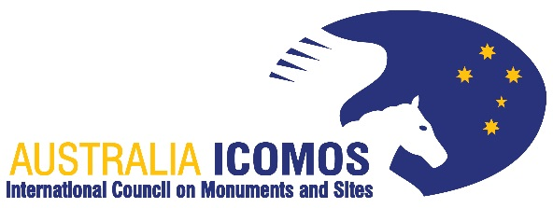 | 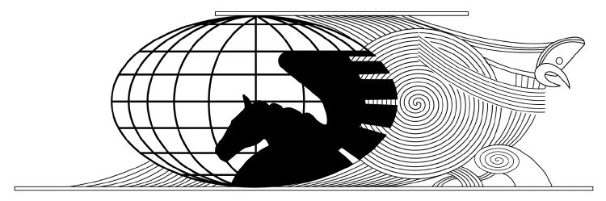
Australia ICOMOS Secretariat  tel: +61 3 9251 7131  e: austicomos@deakin.edu.au  www.icomos.org/australia | ICOMOS New Zealand Secretariat  e: secretariat@icomos.org.nz  http://icomos.org.nz/

AUSTRALIA ICOMOS and ICOMOS NEW ZEALAND
Joint Scientific Committee on Risk Preparedness
ANZCORP

Membership Application
The purpose of the JSC-ANZCORP is to assist Australia ICOMOS and ICOMOS New Zealand to:
- promote the protection of cultural heritage in times of disaster, whether natural or human made, fast or slow onset
- promote cooperation with government, emergency services and civil defence and the inclusion of cultural heritage in emergency plans at local, regional, state and national levels
- build the capacity of heritage professionals in disaster risk management planning and emergency response for cultural heritage, and
- establish a network of professionals that can respond responsibly to emergencies as they arise in the Australian and New Zealand context.
More detailed information about the JSC-ANZCORP is available in the Terms of Reference document https://australia.icomos.org/wp-content/uploads/JSC-ANZCORP-Terms-of-Reference_September-2020.pdf.
There are two levels of membership:

Full Membership is open to full members of Australia ICOMOS and ICOMOS New Zealand with an active interest in promoting the protection and risk management of cultural heritage vulnerable to disaster (both natural and human made, fast and slow onset), including young and emerging professionals.

Affiliate Membership will be open to those that are not members of Australia ICOMOS or ICOMOS New Zealand, but who can contribute their specialist expertise to fulfilling the terms of reference of the JSC-ANZCORP (such as engineers, disaster and emergency management specialists, anthropologists and conservators). Affiliates can participate in JSC-ANZCORP meetings and activities and will be encouraged to apply for Australia ICOMOS or ICOMOS NZ membership where appropriate.

Please complete the information on the reverse side of this form and submit it together with a short current Curriculum Vitae via email to Catherine Forbes (Australia ICOMOS) and Amanda Ohs (ICOMOS New Zealand)—Current Co-convenors.

Contact Information
Title | First Name | Surname
Address |  | Country/State/Territory
 |  | Postcode
Daytime Phone Number |  | Mobile
Email

Membership Category Applied For
Full Member | Affiliate Member
Are you a member of Australia ICOMOS? | Member No. | Category
Are you a member of ICOMOS New Zealand? | Member No. | Category
Would you like to join Australia ICOMOS or ICOMOS New Zealand?
Are you a member of another NSC or ISC

Professional Information
Fields of Specialisation  Please mark all that apply with X |  | Anthropology |  | Structural or Civil Engineering
Fields of Specialisation  Please mark all that apply with X |  | Archaeology |  | Fire Engineering
Fields of Specialisation  Please mark all that apply with X |  | Architecture |  | Disaster Risk Management
Fields of Specialisation  Please mark all that apply with X |  | Cultural Studies |  | Emergency Response
Fields of Specialisation  Please mark all that apply with X |  | Heritage Studies |  | Environment
Fields of Specialisation  Please mark all that apply with X |  | Landscape |  | Site Management
Fields of Specialisation  Please mark all that apply with X |  | Urban Planning |  | Materials Conservation
Fields of Specialisation  Please mark all that apply with X |  | Government Policy |  | Collections Management
Fields of Specialisation  Please mark all that apply with X |  | Other

Briefly outline your interest, and areas of expertise and experience in disaster risk management for cultural heritage.

