MayDay 2018 Logos
Blue Shield Australia is a national committee of the international Blue Shield set up in 1996 to work to protect the world’s cultural heritage threatened by disasters of all types.
Our friends at the Society of American Archivists have once again created this year’s logos. Select the logo relevant to your sector, right click and save as picture and make your own flyer to raise awareness amongst colleagues.

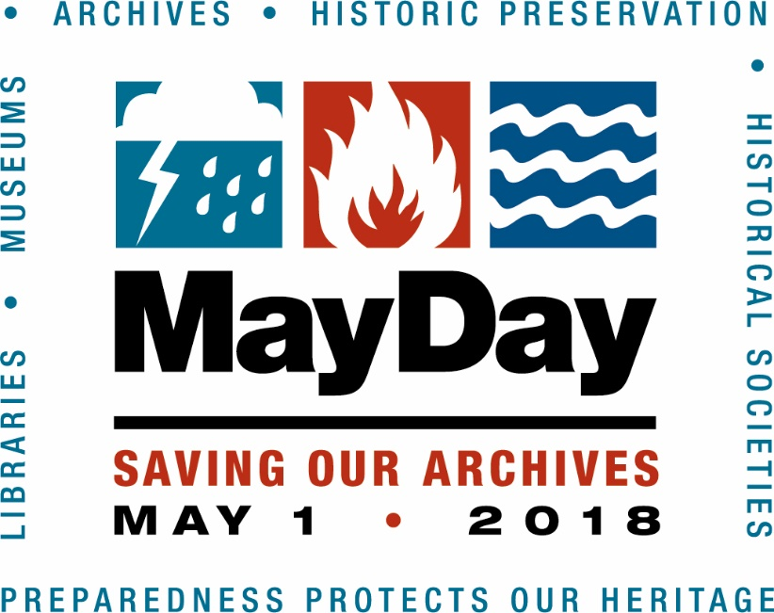

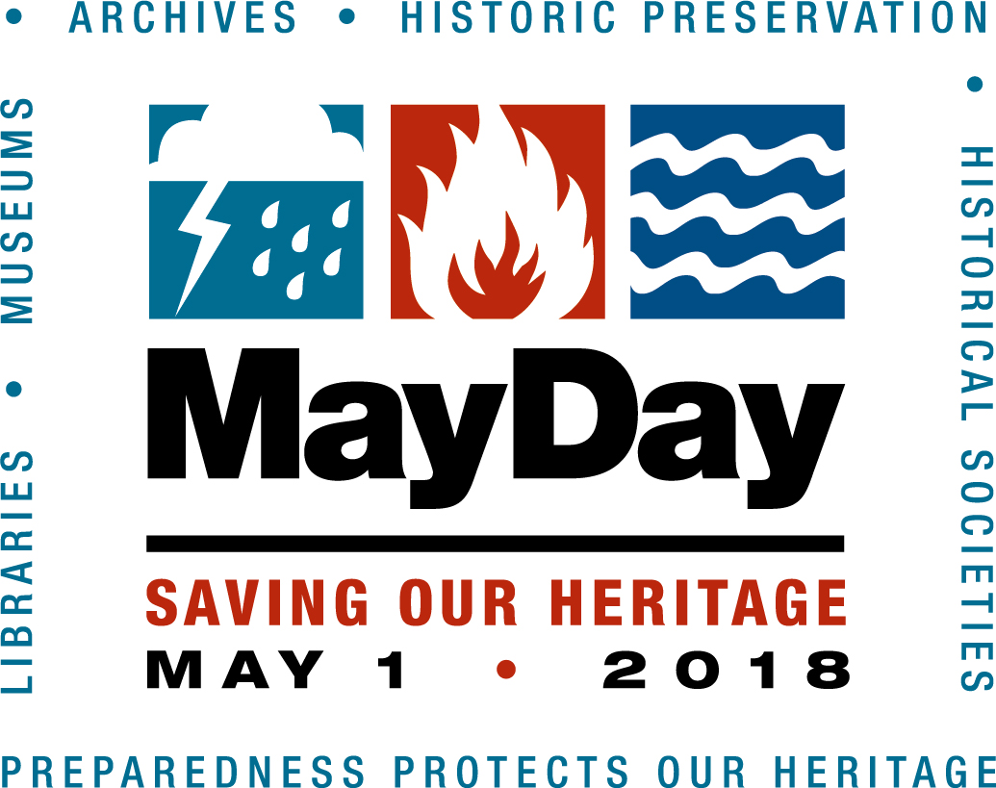

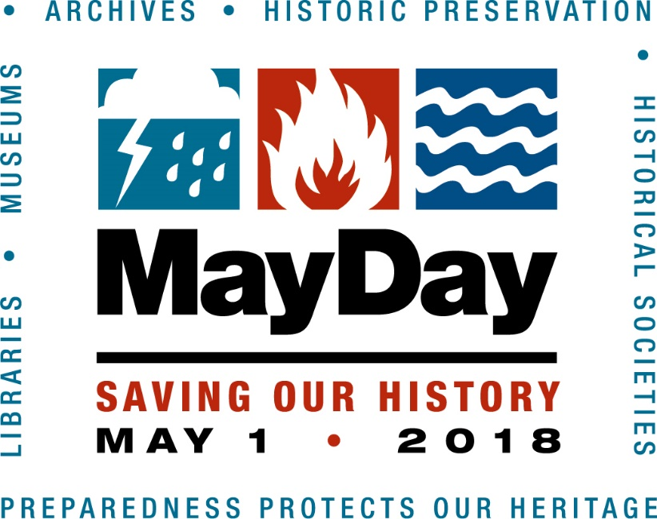

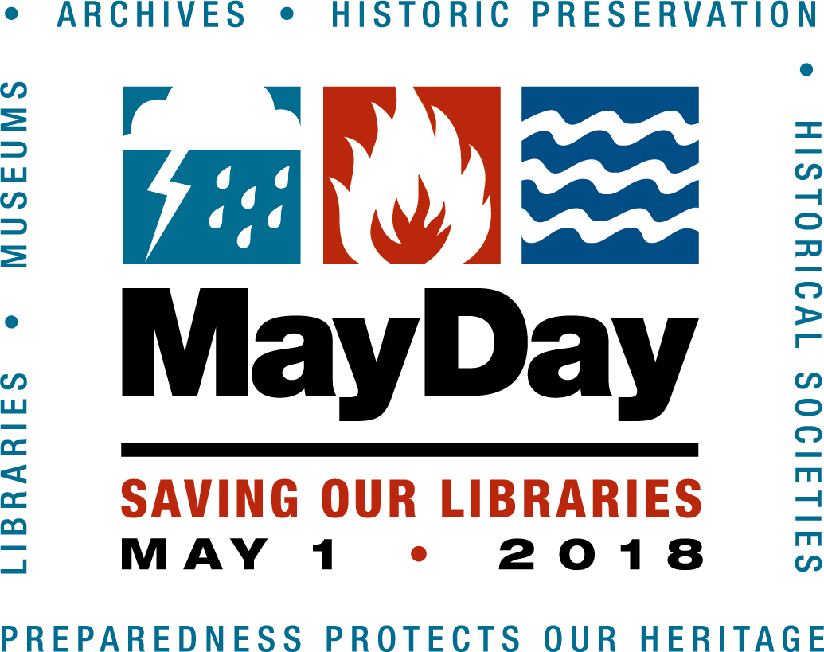

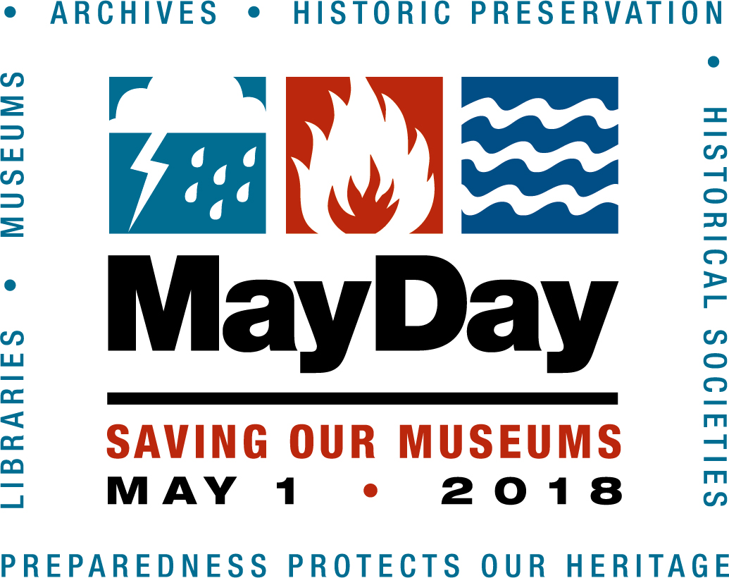

Don’t forget to like us on Facebook

