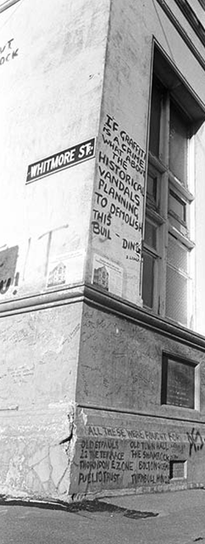
Heritage Matters

Community, Democracy and Heritage

ICOMOS NZ AGM 2016

29-30 October 2016

Wellington



The theme of ICOMOS NZ’s 2016 AGM weekend is “Heritage Matters: Community, Democracy and Heritage”. This theme is exploring the ways in which individual and community groups have been involved in heritage over the decades, and the ways in which groups and individuals have shaped heritage outcomes.
The theme will explore community involvement in heritage, on a local, whanau, regional and national scale.

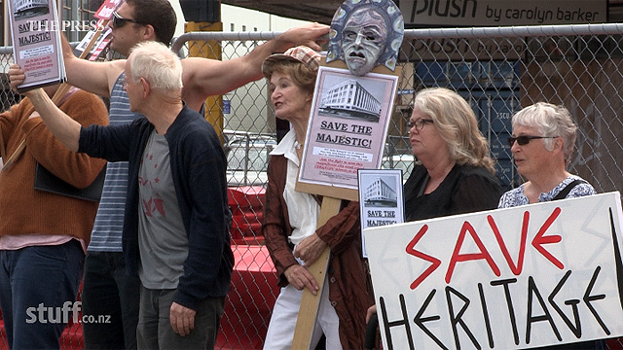

Programme overview
Saturday 29 October
8.30am-9.00am | Registration & coffee
9.00am-1.00 | Papers, including Keynote Speakers
1.00pm-2.00pm | Lunch
2.00pm-3.30pm | Papers
3.30pm-4.00pm | Afternoon tea
4.00pm-5.00pm | AGM
5.00pm-6.00pm | ICOMOS NZ Working Groups networking
7.00pm | Conference dinner
Sunday 30 October
9.00am | Pre fieldtrip paper
9.30am-12.30pm | Fieldtrip
12.30pm-1.00pm | Lunch
1.00pm-2.30pm | Papers
2.30pm | End of conference
3.00pm-4.00pm | Board meeting

Conference Venue:
The conference venue is the Thistle Hall, Upper Cuba St (corner of Cuba St and Karo Drive). This venue and the location are in the centre of Wellington’s Inner City Bypass, which was the subject of major public protest prior to and during its construction in 2004-6.

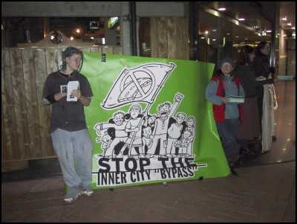
Conference dinner
Saturday 29 October, 7pm
Dinner venue is the Southern Cross tavern, Abel Smith St (www.thecross.co.nz/), about 5 minutes walk from the conference venue. This is a funky bar, with lots of individual internal spaces. We will have our own space, with our own bar & continuous tapas as opposed to a plated sit down meal. This will create an informal networking atmosphere.

Conference fieldtrip
Sunday 30 October, 9.30-12.30
Lower Hutt - Socialism and Democracy in Action.
The field trip will visit the Lower Hutt Town Hall saved by a local group of architects from demolition, and then with a brief tour of central city, a hot bed of radical 1950s Modern Movement buildings. The tour will then visit Nae Nae to look at town planning and community focused developments designed by celebrated Austrian emigre architect, Ernst Plischke.
Lead by Ian Bowman & Ben Schraeder; Ben will give a pre fieldtrip paper on Sunday morning prior to the fieldtrip to set the context.
Commences from conference venue (Thistle Hall). We will stop for morning tea on the way.

Accommodation
There are several accommodation options in close vicinity to Cuba St

Hotels:
- CQ Hotel, 223 Cuba St (this has a 4 star and a 3 star section)
www.hotelwellington.co.nz/
- CPG Hotel, 355 Willis St
www.cpghotels.com/our-hotels/willis-wellington-hotel/

Motels:
- Harbour City Motor Inn, 92 Webb St
www.harbourcitymotorinn.co.nz/
- Victoria Court motor lodge, 201 Victoria St
www.harbourcitymotorinn.co.nz/

Backpackers:
- Lodge in the City, 152 Taranaki St
www.lodgeinthecity.co.nz/

Map
