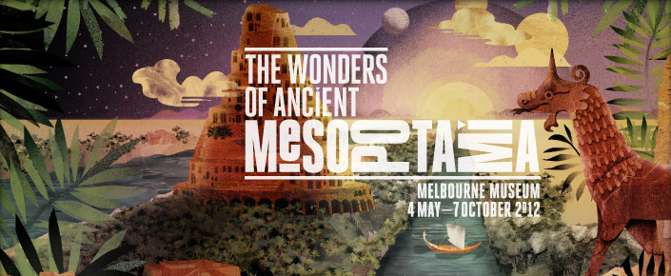

The Destruction of Heritage in Iraq Since 2003

Thursday 6 Sep 2012
Since the invasion of Iraq by coalition forces in 2003, Iraq has endured an extraordinary period of destruction of cultural heritage. This has included the attack on the Iraq National Museum in the very earliest days of the war. Since then, Iraq’s Mesopotamian heritage has also been systematically smuggled out of the country while coalition forces have converted key sites such as the ancient city of Babylon into modern military bases.
This lecture will examine the recent fate of Iraq’s Mesopotamian heritage and discusses the urgent need for appropriate management and protection.

Speaker Biography
Dr Benjamin Isakhan is Australian Research Council Discovery (DECRA) Research Fellow at the Centre for Citizenship and Globalization, Deakin University. He has published widely on the politics and history of Iraq and his current research includes the ARC-funded project ‘Measuring the Destruction of Heritage and Spikes of Violence in Iraq’.
For more on The Wonders of Ancient Mesopotamia exhibition, please see: http://museumvictoria.com.au/melbournemuseum/discoverycentre/mesopotamia/
