
"STONE, GOLD & RARE TRADES"
a weekend of heritage and discovery in the Bathurst area of NSW
11 - 13 May 2018
Register now. Numbers are limited!
Following the announcement in January of our field trip in and around Bathurst NSW,
now is the time to register and pay to attend the tour.

This exciting and weekend is focused on one of Australia's oldest gold mining regions, an area rich in stone structures and our national heritage.

Friday 11 May
5.00pm Group welcome at historic Abercrombie House in Bathurst, including:
- drinks and canapes
- introduction to the weekend
- a talk on the history of Abercrombie House by its owner, Christopher Morgan, ,followed by a tour of the House and its artefacts
- an illustrated talk on Cox's Road, the first road across the Blue Mountains from Sydney, by David Goldney, an expert on Cox's Road.
- the opportunity to stay on for an evening of jazz
7.00pm Dinner: own arrangements.
Accommodation: own arrangements. Abercrombie House is an option

Saturday 12 May
9.00am Depart Bathurst by car convoy
10.00am Tour of the historic Br=idle Track connecting Bathurst to the gold mining town of Hill End, visiting dry stone embankments and structures. Morning tea along the way.
12.30pm Picnic lunch beside the Turon river. Talk about the history of the area Bridle Track by local identity Paul .
Car convoy, with some walking, to see early dry stone structures along the Track, noting rock walls, culverts, bridges and remains of old stone/wattle and daub houses such as “Boxwood”, owned by Garry Browne and “Mountain View” once owned by Percy Gresser, an early Australian shearer.
3.00pm Arrive Hill End
Guided walking tour of the gold rush town, with time to visit the History Hill Museum.
5.30pm Meeting and drinks at the Royal Hotel
6.00pm Group dinner at the Royal Hotel, with guest speaker and local historian Malcolm, custodian of the History Hill Museum. We have booked out the hotel and accommodation is available for up to 20 guests in single, twin or double rooms. Other accommodation options are available in Hill End. See booking details below.

Sunday 13 May
8.00am Breakfast for those people staying at the Royal Hotel.
9.00am Depart by car convoy to Sofala.
10.00am Walking tour of Sofala
11.00am Depart Sofala and return to Bathurst
12.30pm Attendance at the Rare Trades Heritage Trail in Bathurst. This celebration of old trades, crafts and traditional skills includes a dry stone walling demonstration supported by DSWAA and conducted by wallers Wayne Fox and Emma Knowles. Food and drinks are available for purchase.
5.00pm Tour and activities conclude.
7.00pm Dinner at a local venue (at own cost).

Cost
Cost: $130 per person. This includes:
- welcome drinks on Friday
- picnic lunch on Saturday
- group dinner on Saturday at the Royal Hotel in Hill End.
- admission to the Rare Trades Heritage Trail venues and the DSWAA wall demonstration
- maps and tour notes.

Not included:
- travel to and from Bathurst
- accommodation
- dinner on Friday evening
- drinks, other than at the Friday welcome
- lunch on Sunday
- any costs incurred on the Monday.

Accommodation at the Royal Hotel, Hill End on Saturday night 12 May
We have booked out all rooms at the iconic Royal Hotel. Bed and breakfast is available for $40 per head. See Booking Form below.

Other accommodation is available in Hill End. If not staying at the Royal Hotel, you should make your own arrangements. .

Monday 14 May
For those wanting to explore Bathurst and its region further, advice and information will be available for you to visit, on:
- historic sights in Bathurst
- Mount Panorama race circuit and lookout
- key features along Cox's Road,
- Mayfield Gardens, a historic property and garden near Oberon, rich in modern dry stone walls.

Booking Form
NAME(S): .............................................................................................

EMAIL ADDRESS: .................................................................................

MOBILE PHONE: ..................................................................................

SATURDAY NIGHT ACCOMMODATION
I/we want to stay at the Royal Hotel in Hill End on Saturday night: YES/NO
Type of room: please indicate: single / twin / double

PAYMENT
Please transfer funds to DSWAA: BSB: 013-373, Account No: 4997 47356.
Amount: $130 per person
OR
$130 + $40 = 170 per person if staying at the Royal Hotel.

BOOKINGS CLOSE ON 25 APRIL

NUMBERS ARE LIMITED, PARTICULARLY FOR OVERNIGHT ACCOMMODATION AT THE ROYAL HOTEL.

Once your booking is received, we'll get back to you with further details of the weekend, including a map of Bathurst and the location of Abercrombie House (meeting point on Friday evening).

Useful links
Abercrombie House
http://www.abercrombiehouse.com.au/

Bridle Track
https://www.facebook.com/groups/497622283745898/?ref=bookmarks

History Hill Museum, Hill End
http://www.historyhill.com.au

Royal Hotel, Hill End
http://www.royalhotelhillend.com/

Rare Trades Trail
Bathurst Heritage Trades Trail

Cox's Road
http://coxsroaddreaming.org.au

Mayfield Garden
http://mayfieldgarden.com.au/the-mayfield-story/

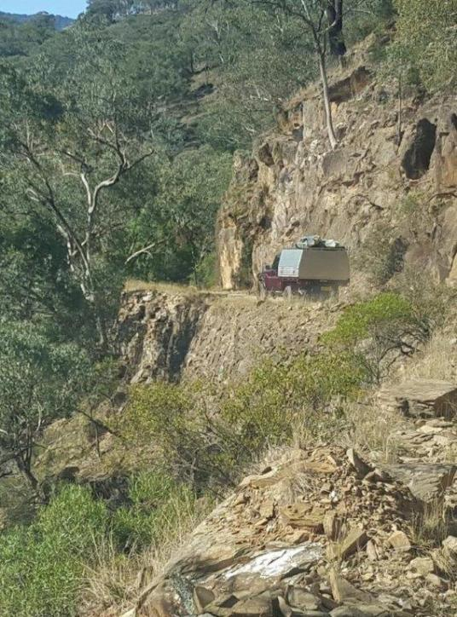
DRY STONE EMBANKMENT ON THE BRIDLE TRACK

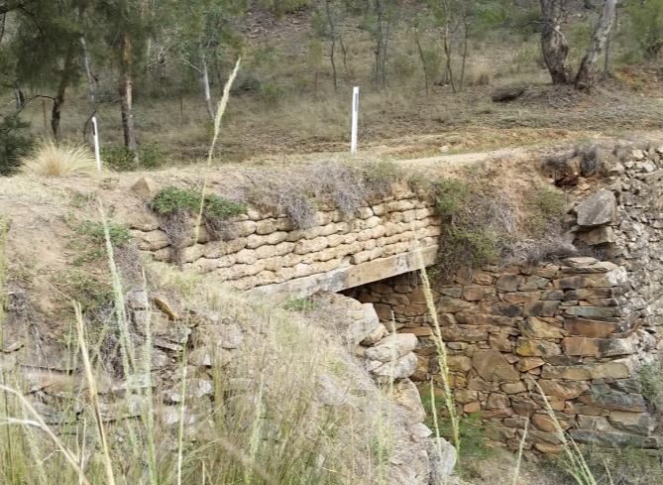
DRY STONE CULVERT ON THE BRIDLE TRACK

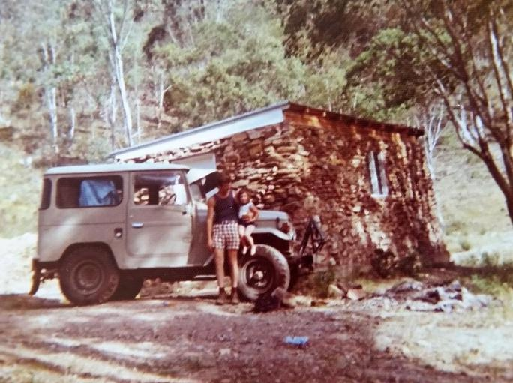
STONE HUT

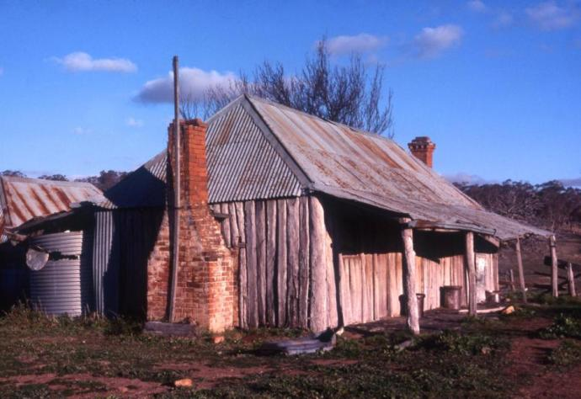
TIMBER SLAB COTTAGE

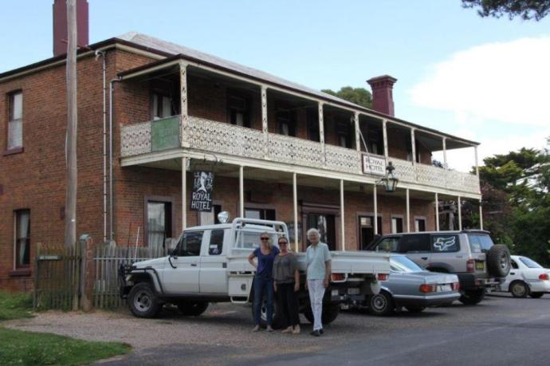
ROYAL HOTEL, HILL END

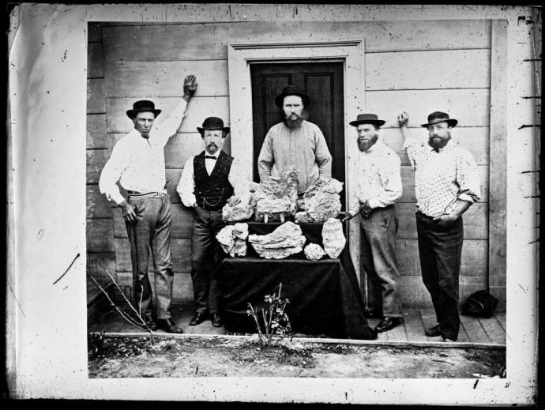
SUCCESSFUL PROSPECTORS

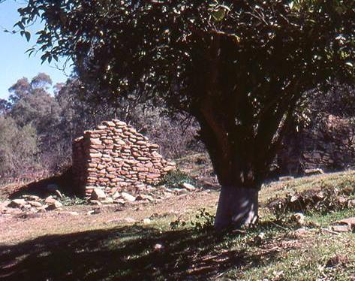
REMNANTS OF STONE HUT

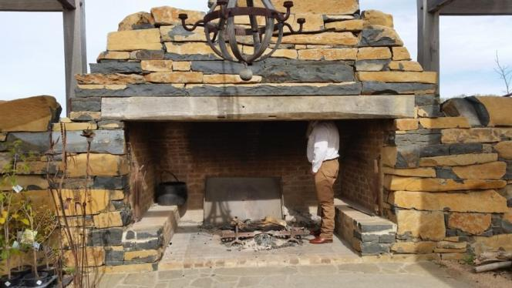
DRY STONE FIREPLACE, MAYFIELD GARDEN

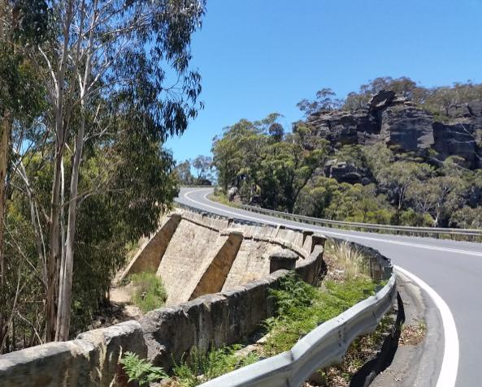
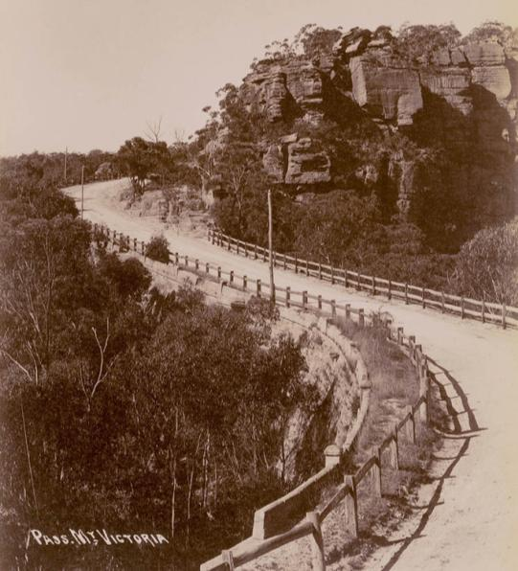
COX'S ROAD AT MT VICTORIA PASS

