Tocdog Elementary School, Loay, Bohol – Conservation of Gabaldon School

The Tocdog Elementary School restoration project, the second Gabaldon-type schoolhouse to be conserved by Streetwise Asia, (on Bohol Island in the Southern Philippines) has now been completed. As for the first project in Camiguin Island, a heritage school building in very poor condition has been conserved and restored, with upgraded toilet facilities provided. The following are photos of this project (including one of the community vegetable garden):

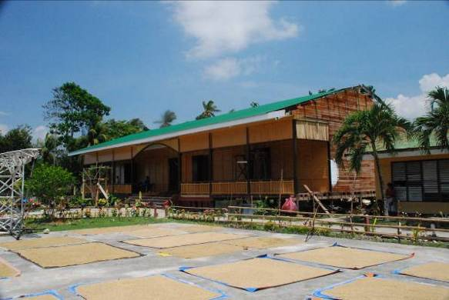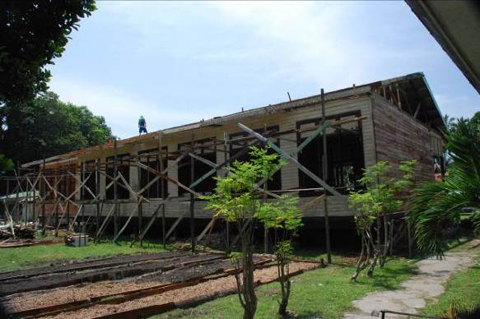

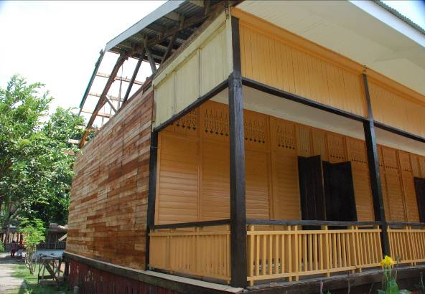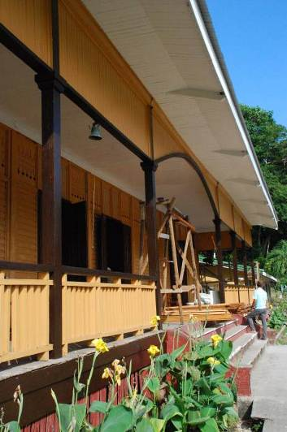

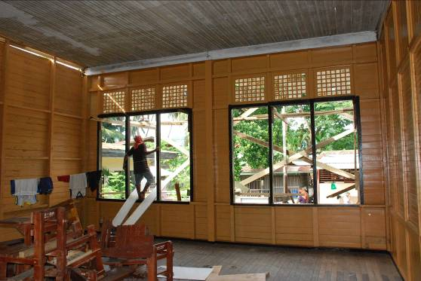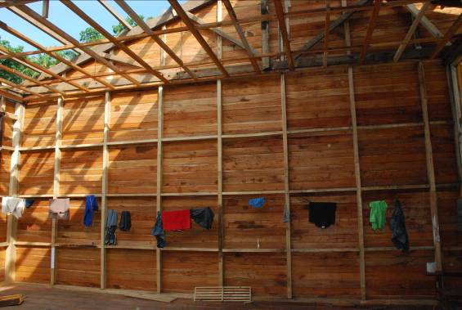

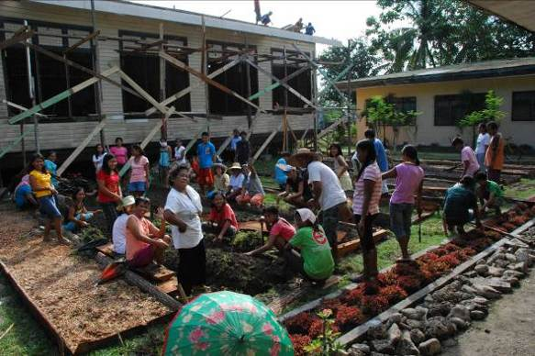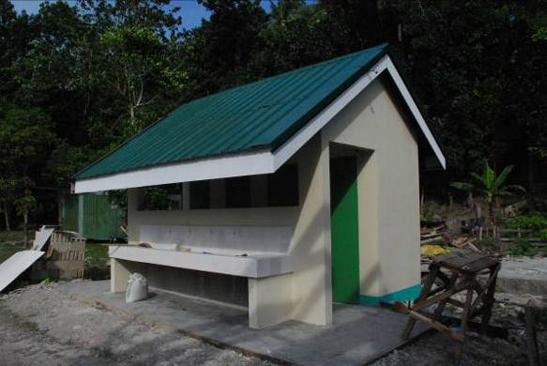

General information on the “Gabaldon Schools” - these schools are now widely recognised in the Philippines for their heritage value as an important group of approximately 3000 school buildings erected during the American colonial period (1898 – 1946). Many are in a poor condition (or empty due to neglect) and are under appreciated for their potential resource as restored school buildings or adaptive reuse for other community uses. The Philippines Education Department has previously initiated a program to undertake maintenance work on the Gabaldon Schools, but with over 3,000 in existence, many are in poor condition or derelict and the task is overwhelming. The AusAID and Streetwise commitment has put funding possibilities on a new level. AusAID have indicated their interest in continuing their participation in the Gabaldon Restoration Program together with DepEd and the Heritage Conservation Society. It has been demonstrated that the cost of conserving and upgrading a heritage building can match the cost of a new classroom building of equivalent area. This conservation approach has huge potential. There is no comparison between a Gabaldon School, (with its high ceilings, timber windows and elegant detailing) and a new concrete and steel classroom building, but classroom provision is the primary consideration of AusAID and Philippines DepEd.

The two completed Streetwise projects have resulted in new and important partnerships being generated between Streetwise, AusAID, the Philippines Department of Education, Philippines ICOMOS and the Philippines Heritage Conservation Society all of whom have in some way been involved in the school projects.

In visiting other possible future schools for Streetwise support, both Liz Vines (the Streetwise Asia Coordinator) and Bruce Dawbin (volunteer conservation architect for the projects) have been deeply affected by the lack of provisions for basic education. Classrooms with 40 – 50 children are common, and one typical primary school had 800 students, with one computer and no printer! We have so much that we take for granted in our Australian education system. Bruce has also now facilitated the donation of second hand lap tops and phones, which have transformed the local teacher’s capacity.

For more information on the Kuguita project, see the Philippine Enquirer article of 22 May<http://lifestyle.inquirer.net/artsandbooks/artsandbooks/view/20100524-271665/Philippine-Australian_cooperation_restores__Gabaldon-type_school_in_Camiguin>

Or contact Liz Vines on liz@mcdougallvines.com.au or 0419 816 525 if you are interested in further information or helping in any way with the Streetwise fund project.

