The Cultural Heritage Centre for Asia and the Pacific

has great pleasure in inviting you to a special public lecture

Thursday 16 April 2015, 6 pm – 8.00 pm

Deakin City Centre, Level 3, 550 Bourke Street, Melbourne.
Conjugating the past present and future: human rights issues in cultural heritage, history teaching and memorialisation processes

Farida Shaheed
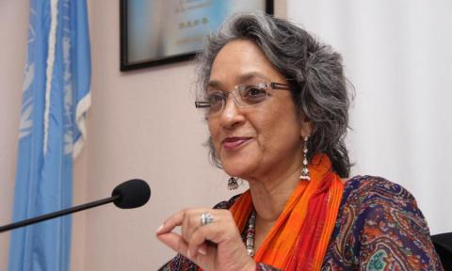
FFarida Shaheed has been Independent Expert and Special Rapporteur on Cultural Rights at the Office of the UN High Commission for Human Rights in Geneva for the past five years. She has been a strong advocate for maintaining and strengthening people's access to and enjoyment of cultural rights in countries around the world. She has conducted numerous fact-finding missions including to Botswana and Vietnam and she reports regularly to the UN Human Rights Commission.

Her UN reports range across many cultural rights themes including:
- Access to cultural heritage as a human right
- Cultural rights of women
- Historical and memorial narratives in divided societies
- History teaching and memorialization processes
- Copyright policy and the right to science and culture
- The impact of advertising and marketing practices on the enjoyment of cultural rights.
Free Event.
All are welcome. As seating is limited, please ensure you have made a booking by emailing andrea.witcomb@deakin.edu.au by 15 April 2015.

